
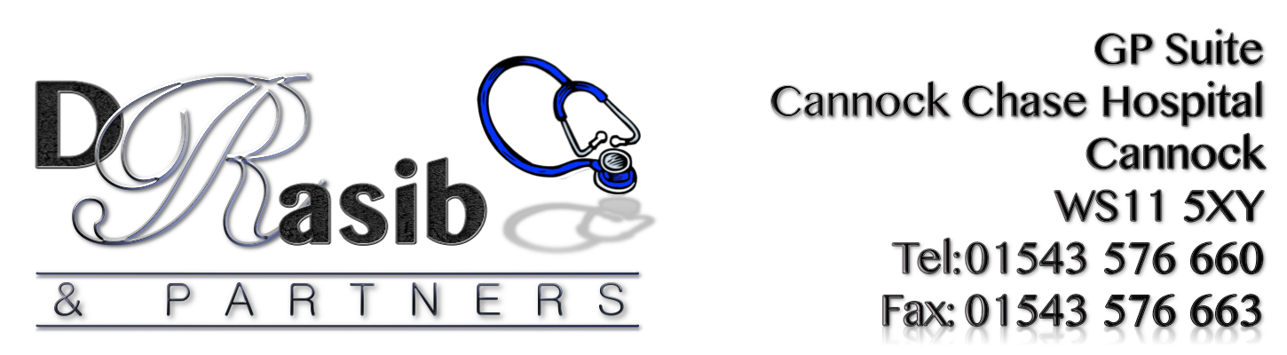

NHS FRIENDS & FAMILY TEST

“HOW LIKELY ARE YOU TO RECOMMEND OUR SERVICE TO
FRIENDS AND FAMILY IF THEY NEEDED SIMILAR CARE
OR TREATMENT?”

April 2018 RESULTS





Extremely Likely | Likely | Neither Likely/ Unlikely | Unlikely | Extremely Unlikely | Don’t Know
23 | 10 | 3 | 0 | 0 | 0

Comments Received from Patients included:
‘Positive Practice’
‘All staff friendly, reception girls very helpful. Recommended to a lot of people already’
‘I was advised this surgery by a family member, been here a while now and it’s the best practice ever. So pleased I moved’
‘Best Surgery’
‘Friendly surgery, helpful’
‘Reception are always smiling. It’s a joy to come to this surgery’
‘Surgery provides a great service’
‘Doctors always have time for you’
‘Always very polite and caring’
‘Always given the correct hep and never had any issue’s. Very good surgery, would not move’

HAVE YOUR SAY TODAY…
COMPLETE A FRIENDS & FAMILY QUESTIONNAIRE

